**EXPERIMENT 3: CONVERSION BETWEEN AMMETER AND VOLTMETER**

Name: Asmito Ghosh  
Registration No: IACS02721  
Group No: A2  
Date of Experiment: 26.08.2024

OBJECTIVE:

* To convert a given voltmeter to an ammeter of suitable range and calibrate the ammeter so prepared.
* To convert a given ammeter to a voltmeter of suitable range and calibrate the ammeter so prepared.

THEORY:

* A voltmeter is designed to measure voltage by having a high internal resistance, ensuring it draws negligible current from the circuit.
* Hence, the voltage drop measured across the resistance by a voltmeter is also almost the same as the voltage drop without the voltmeter across the resistance.

rv >> R

* An ammeter is designed to measure current by having a low internal resistance, allowing maximum current flow with minimal voltage drop.
* Hence, the current measured by the ammeter is approximately equal as current without the ammeter in the circuit.

rA<< R

Part A: Conversion of Voltmeter to Ammeter:

* To convert a voltmeter into an ammeter, a low resistance (shunt) is connected in parallel with the voltmeter. This allows the device to measure the total current flowing through a circuit.
* To calculate the shunt resistance, the resistance of the voltmeter is required. This is measured by half-deflection method:

I0 = V0 / (R + rv)

At half deflection:

R = rv

⇒ I0 = V0 / 2rv

After determining rv :

Ish = I0 – I  
Rsh = V0 / Ish

Circuit Diagram for Conversion of Voltmeter to Ammeter:

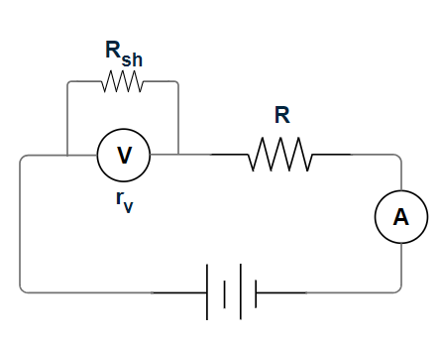

Part B: Conversion of Ammeter to Voltmeter:

* An ammeter is designed to measure current by having a low internal resistance, allowing maximum current flow with minimal voltage drop.
* To convert an ammeter into a voltmeter, a high resistance is connected in series with the ammeter. This allows the combination to measure voltage across a component while drawing minimal current.
* The converted voltmeter can be calibrated to read voltage directly by ensuring the measured current corresponds to the potential difference across its terminals.
* To make ammeter full-scale to read full-scale voltage Vo, the remaining voltage V = V0 – Va should drop across R and from this consideration we calculate series resistance as, Vss/ Rss= VA/ rA

⇒Rss = (rA*Vss)/VA

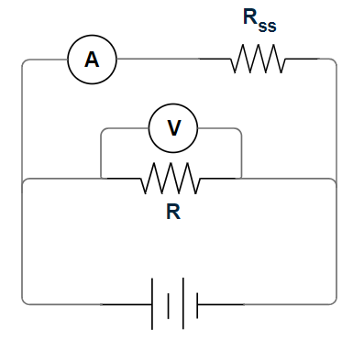

APPARATUS REQUIRED:

* Ammeter
* Voltmeter
* Resistors of known resistance (both high and low values)
* Battery or DC power supply
* Rheostat
* Connecting wires

PROCEDURE:

* The first step to convert a voltmeter to an ammeter is to determine the resistance of the voltmeter.
* Keeping R = 0, the supply voltage E was adjusted so that the voltmeter shows large readings V.
* Suitable R was chosen to reduce the voltage recorded in voltmeter to half (V /2).
* Voltmeter resistance was then rv = R.
* Calculated the shunt resistance Rs. Using a ammeter, appropriate range was set as the standard ammeter.
* Changing the supply voltage for a fixed R (chosen such that the maximum current in the circuit is little above I0), the converted and the standard ammeter readings were recorded as Inew and Istandard.
* To begin converting an ammeter to a voltmeter, the resistance ra of the ammeter was determined. The resistance R in series with the ammeter was kept at large value to prevent large current from flowing through the ammeter and damaging it.
* Resistance R was changed appropriately and each time the voltage drop across it (Vr) was measured with a voltmeter.
* Calculated ra from these set of readings.
* Calculated the series resistance. Using a voltmeter, appropriate range was set as the standard voltmeter.
* Changing the supply voltage for a fixed R (chosen such that the maximum voltage in the circuit is little above V0), the converted and the standard voltmeter readings were recorded as Inew and Istandard

RESULTS:

Part A: Conversion of Voltmeter to Ammeter:

Measurement of Voltmeter Resistance:

|  |  |  |  |  |  |  |
| --- | --- | --- | --- | --- | --- | --- |
| Sl no. | Full Deflection | | Half Deflection | | rv  (k Ω) | Avg. rv  (k Ω) |
|  | V0 (V) | R(Ω) | V0/2 (V) | R(k Ω) |  | 11.21 |
| 1 | 10.0 | 0.00 | 5.0 | 11.20 | 11.20 |
| 2 | 9.6 | 0.00 | 4.8 | 11.20 | 11.20 |
| 3 | 9.2 | 0.00 | 4.6 | 11.21 | 11.21 |
| 4 | 8.8 | 0.00 | 4.4 | 11.22 | 11.22 |
| 5 | 8.4 | 0.00 | 4.2 | 11.24 | 11.24 |

rv= 11.21 k Ω

I = V0/rv = (10/11.21) mA= 0.892 mA

Ish= I0 – I= (10-0.892)mA = 9.108 mA

Rsh = V0/Ish

=10/9.108 k Ω

≈ 1.10 k Ω [Theoretical value of Rsh]

Experimentally, Rsh = 1.11 k Ω

Calibration of Converted Ammeter:

|  |  |  |  |
| --- | --- | --- | --- |
| Sl no. | Converted Ammeter (Inew) (mA) | Standard Ammeter  (Istandard) (mA) | Correction  (Inew – Istandard) (mA) |
| 1 | 8.2 | 8.2 | 0.0 |
| 2 | 6.4 | 6.4 | 0.0 |
| 3 | 5.0 | 5.0 | 0.0 |

Any possible correction is less than L.C of converted Ammeter, hence cannot be recorded.

Measurement of Ammeter Resistance:

|  |  |  |  |  |  |
| --- | --- | --- | --- | --- | --- |
| Sl no. | V0 (V) | R (k Ω) | VR (V) | rA (k Ω) | Average rA  (k Ω) |
| 1 | 4.93 | 4.00 | 4.92 | 0.008 | 0.010 |
| 2 | 6.02 | 7.00 | 6.01 | 0.012 |
| 3 | 7.03 | 6.00 | 7.02 | 0.009 |

rA= 0.010 k Ω  
VA= I0*RA= (0.010*10) V=0.10V

V0=10.00V

V= V0-VA= (10.00-0.10) V=9.90V

I= (VA/RA) = (V/R)

Rss= (ra*Vss)/VA

= {(0.01*9.9)/0.1} k Ω

= 0.99 k Ω [Theoretical value of Rss]

Experimentally, Rss = 1.03 kΩ

Calibration of Converted Voltmeter:

|  |  |  |  |
| --- | --- | --- | --- |
| Sl No. | Converted voltmeter  (Vnew) (V) | Standard voltmeter (Vstandard) (V) | Correction  (Vnew -Vstandard) (V) |
| 1 | 4.0 | 4.0 | 0.0 |
| 2 | 5.0 | 5.0 | 0.0 |
| 3 | 6.2 | 6.4 | -0.2 |

ERROR ANALYSIS:

Part A: Conversion from Voltmeter to Ammeter:

Rsh (experimental) =1.11 k Ω

Rsh (Theoretical) =1.10 kΩ

Percentage error in Rsh = * 100%

= 0.91 %

Part B: Conversion from Ammeter to Voltmeter:-

Rss (experimental) =1.03 kΩ

Rss (Theoretical) =0.99 kΩ

Percentage error in Rss calculation = $\frac{R_{ss }\left(Experimental\right)-R_{ss}(Theoretical)}{R_{ss} (Theoretical)}$* 100%

= 4.04 %

REMARKS:

Therefore, an ammeter can be converted to voltmeter and vice-versa by determining the internal resistance and then adding appropriate resistance in shunt or series, as applicable.

SNAPSHOTS OF LABORATORY NOTEBOOK:

